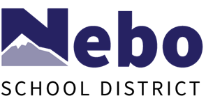
RETIREMENT
Retiree Information Request

Congratulations on your decision to retire! Your outstanding service with Nebo School District is greatly appreciated. In May, a Retirement Luncheon will be held in your honor. Additional information is forthcoming. Please complete the following form and submit it with your photo by April 1 to:

Nikki Kelepolo
Human Resource Department,
350 South Main, Spanish Fork, Utah 84660
Email: nikki.kelepolo@nebo.edu
801-354-7414

If a photo is not submitted with your information, your current school photo will be used. The information you submit will be included in a Retirement Booklet and also used in an article in the Nebo News and on the District’s website. An electronic version of this form can be found at www.nebo.edu. Click on “Departments,” “Human Resources,” then look under “Forms” and click on “Retirement Information Form”.

Once completed, you may personally deliver or send the information via email (preferred), U.S. Mail, or the IMC.

Name Address

Title/Position School/Location

Grades/Subjects

Total Years: Nebo District Other District Total Years for Retirement

Personal feelings, sentiments, or who has made a difference.

Please email or enclose a photo! Thank you. Version 2018

